Data Analytics (DA)
Module -2
Power BI Assignment 2 – DAX & Data Visualization
DAX Calculations
Calculated Columns
● Create a Calculated Column for 'Category Type': 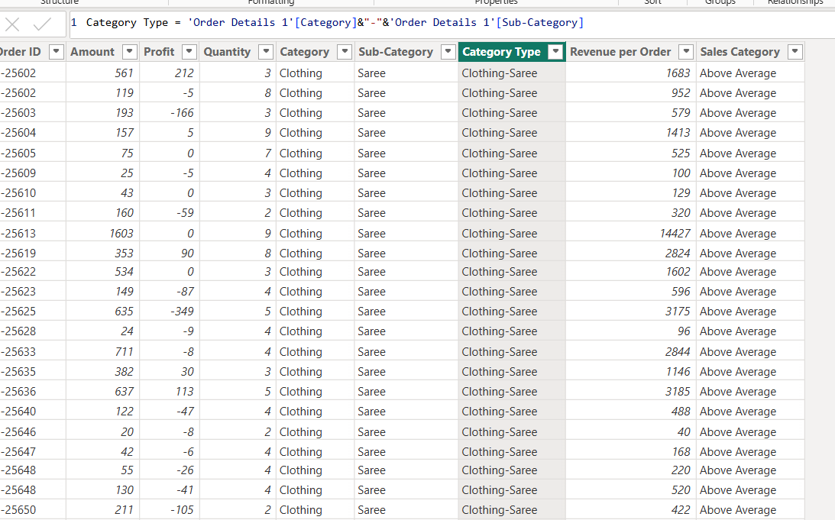
● Calculate Revenue per Order in Order Details Table:
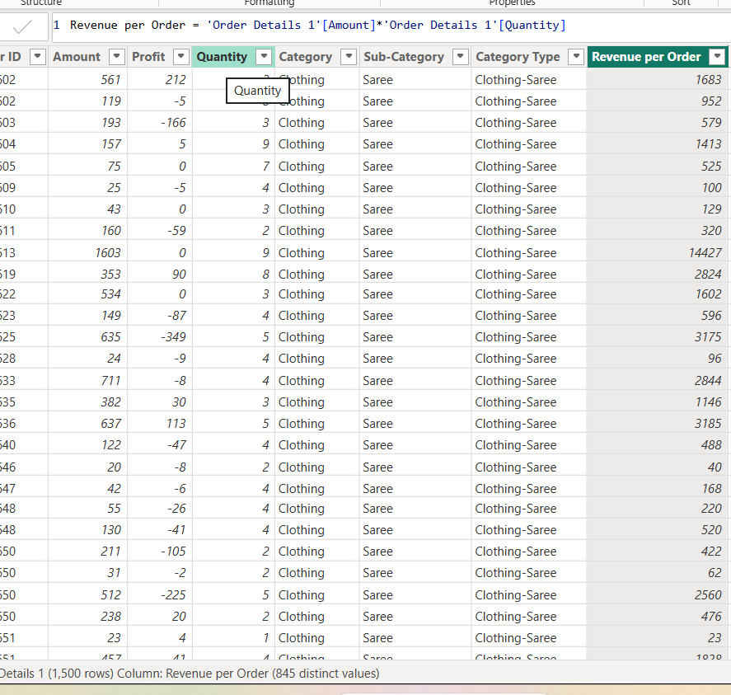

● Create a Calculated Column to Categorize Sales:
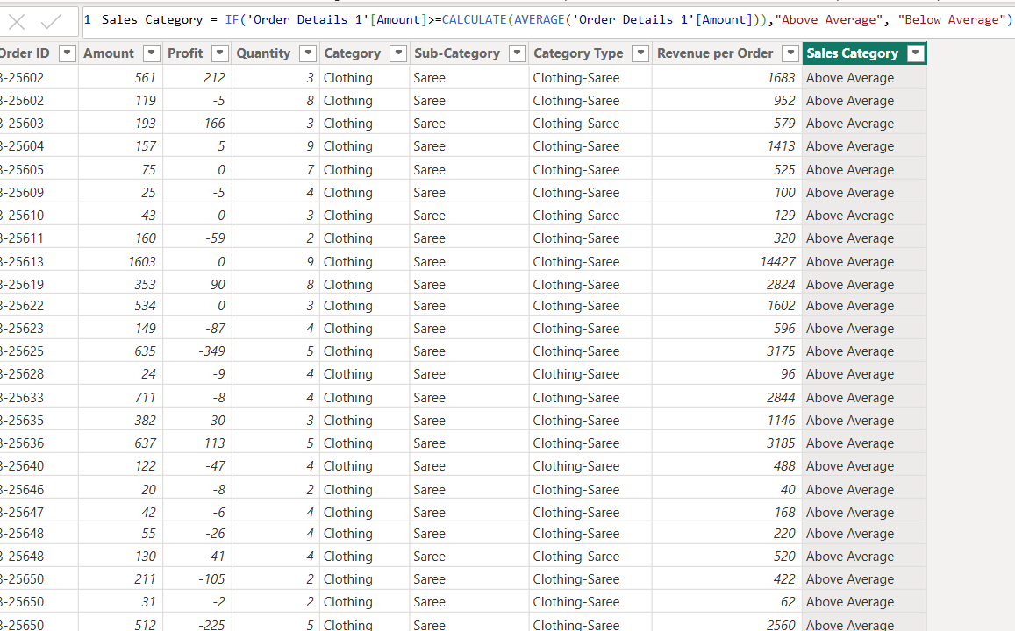
Calculated Measures
- Order Count-
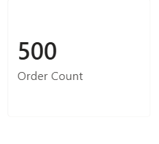
- Average Profit in Delhi

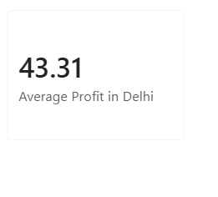

- Year-to-Date (YTD) Sales

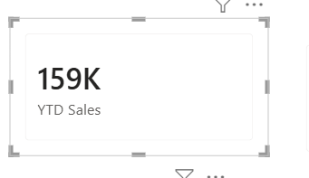

Data Visualization

● Sales Target Achievement by Category:

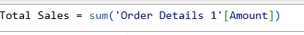

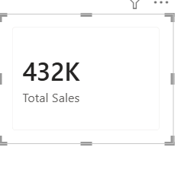

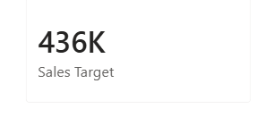
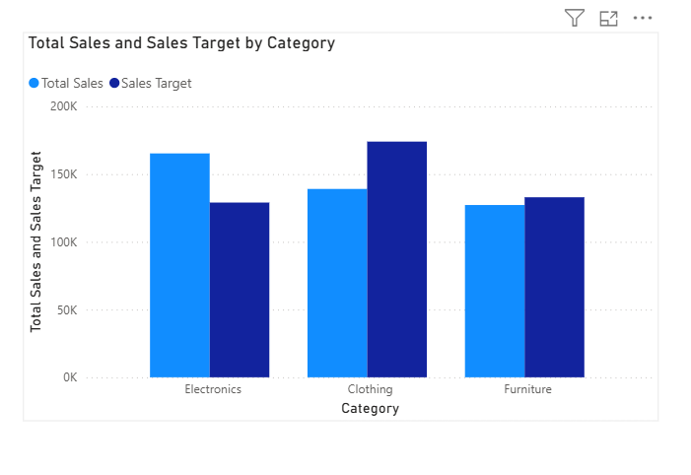
● Max Profit Margin by Sub-Category:

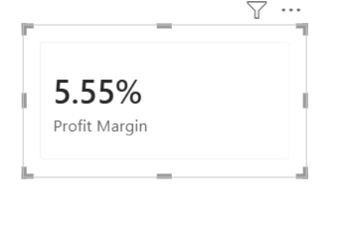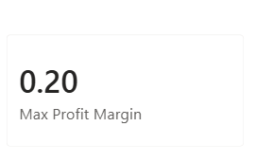

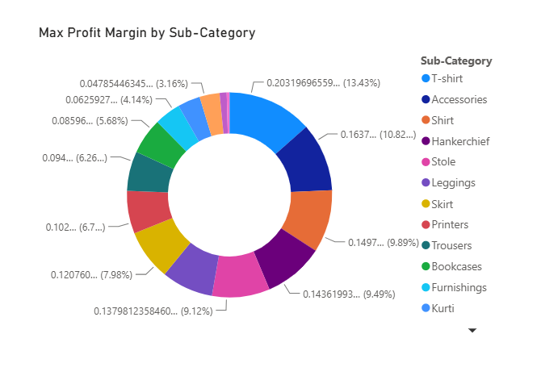
● Monthly Sales Trend

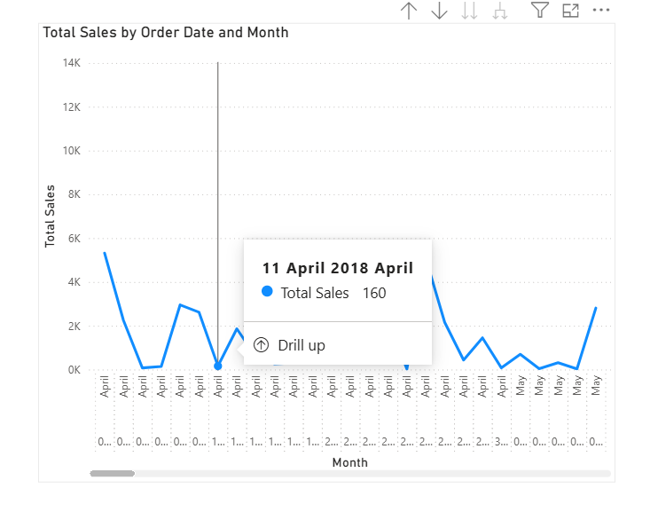

● Comparison of Profit and Quantity by Sub-Category

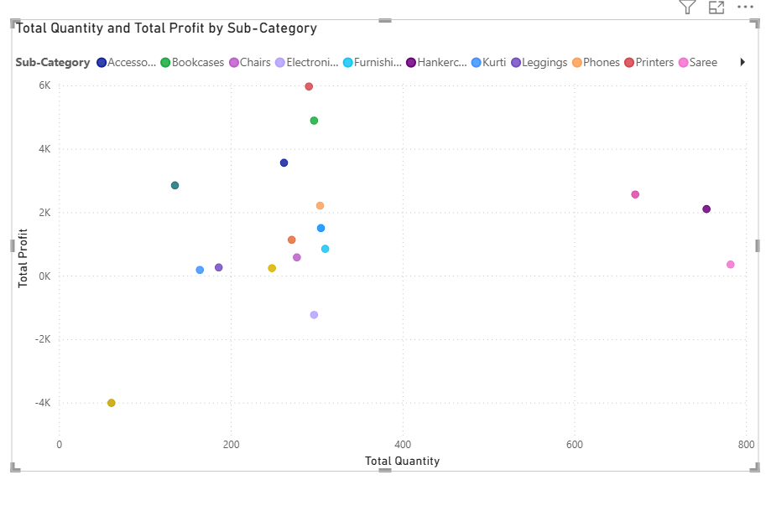
● Sales Performance Matrix:

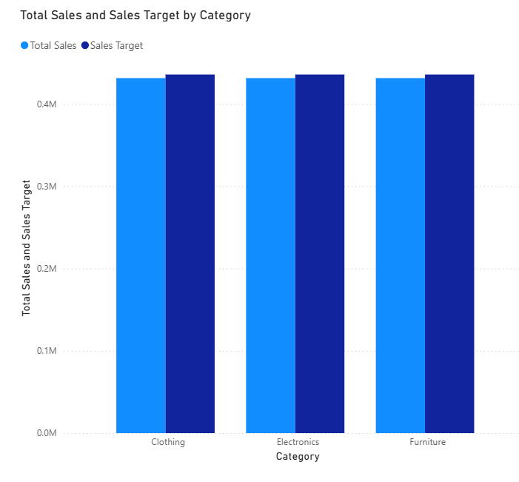
● Geographic Sales Analysis:

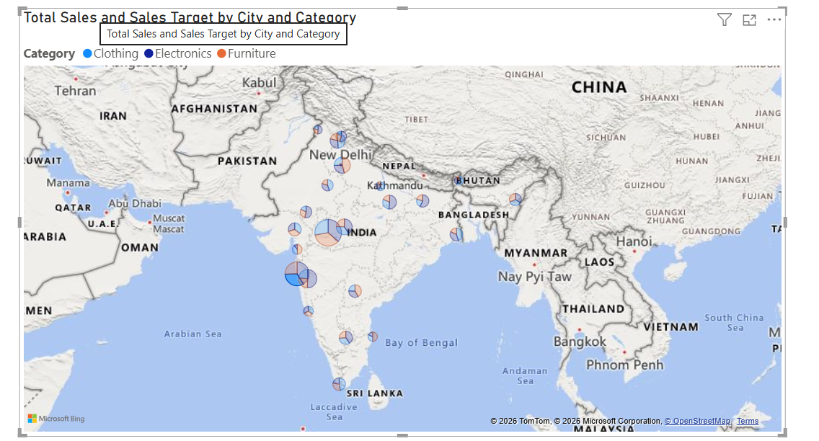

● Sales Distribution by Sub-Category using treemap:

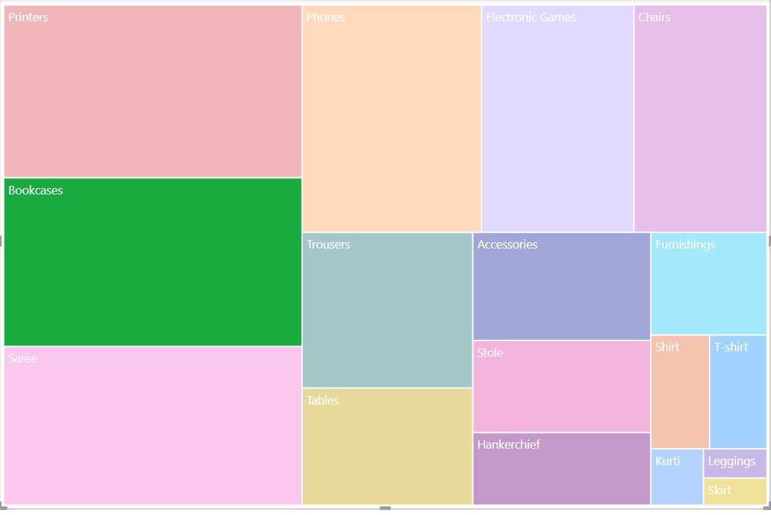
● Order Count Analysis by State: